Exercise 5.2 Week 9-10

1 heat map, 1 spatial chart and 1 contour chart using R











Using Python-

1 heat map, 1 spatial chart and 1 contour chart using Python

Heat map

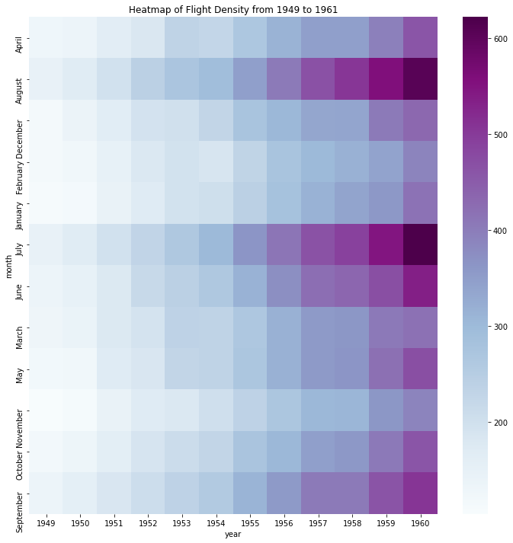

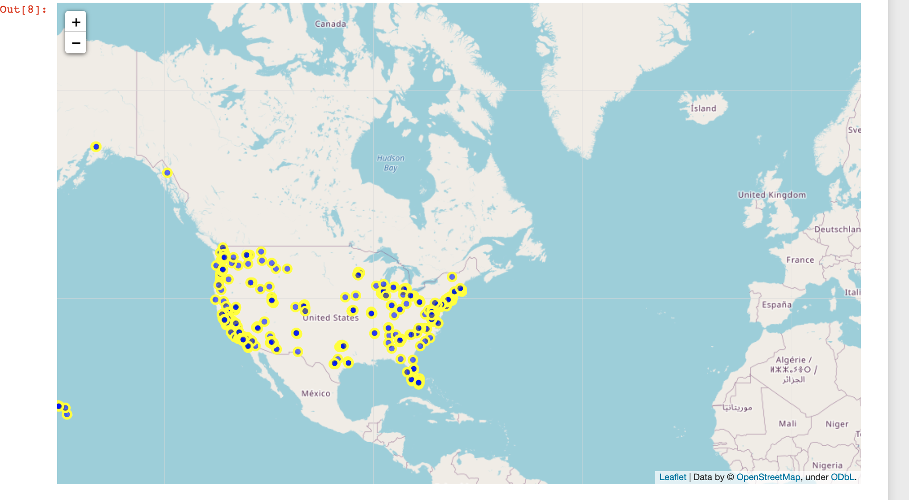

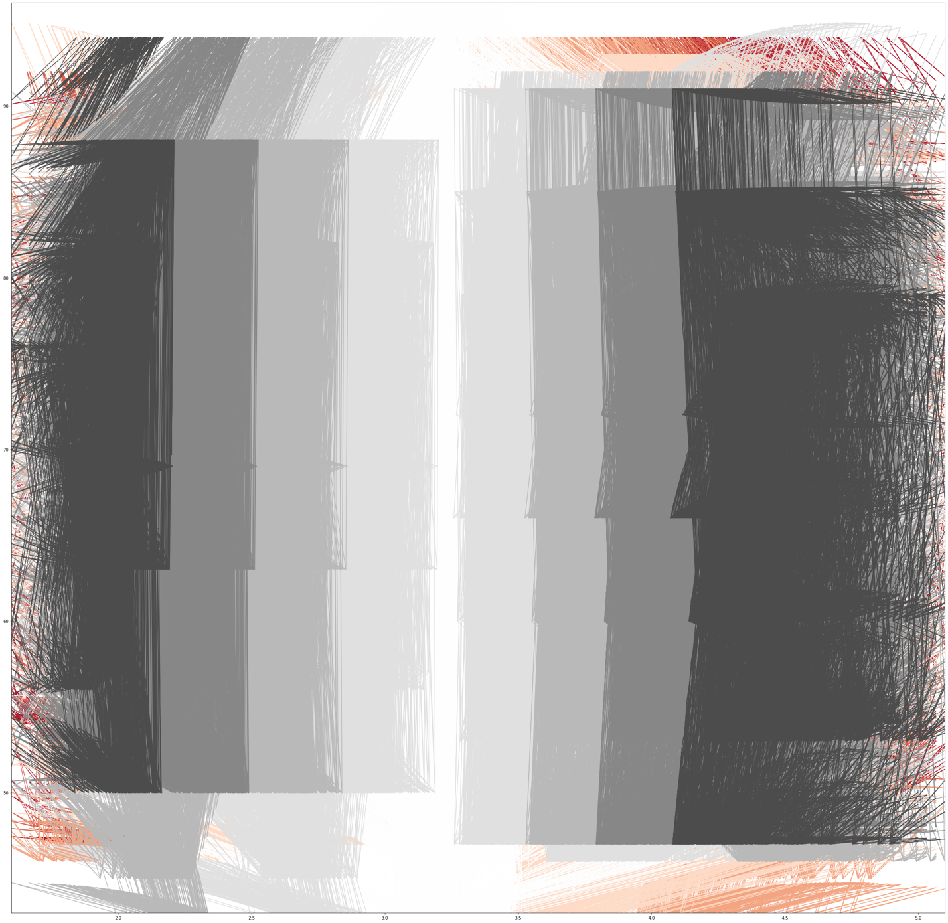

1 heat map, 1 spatial chart and 1 funnel or violin chart using Tableau or PowerBI